**Paste Project Title Here**

Senior Project

by

**Mohamad Khalife**

**Mohamad Swaydan**

Submitted to the School of Engineering of the

Lebanese International University

Beirut, Lebanon

in partial fulfillment of the requirements for the degree of

**BACHELOR OF SCIENCE IN COMMUNICATION ENGINEERING**

**Fall 2021-2022**

**Approved by:**

**Supervisor**

Dr. Zouhair Bazzal

**Committee Member**

Dr. TBA

**DEDICATION**

To someone I know and I care for

John J. Doe

To someone I know and I care for

Jane D. Doe

**ACKNOWLEDGMENT**

We would like to thank our supervisor and the dean and the rest of the people who spared no effort in

**ABSTRACT**

The abstract goes here with double space 12pt font. The abstract consists of one paragraph with first line indentation. The page should be numbered. The abstract goes here with double space 12pt font. The abstract consists of one paragraph with first line indentation. The page should be numbered. The abstract goes here with double space 12pt font. The abstract consists of one paragraph with first line indentation. The page should be numbered. The abstract goes here with double space 12pt font. **The abstract consists of one paragraph with first line indentation**. The page should be numbered. The abstract goes here with double space 12pt font. The abstract consists of one paragraph with first line indentation. The page should be numbered.

**TABLE OF CONTENTS**

**LIST OF FIGURES**

**LIST OF TABLES**

**LIST OF SYMBOLS**

MUST LISTED IN ASCENDING ALPHABETICAL ORDER. Examples:

Ω: Resistance

μ: Viscosity

A: Ampere

BW: Bandwidth

CD: Compact Disk

COVID: Corona Virus Disease

ISO: International Standardization Organization

LCD: Liquid Crystal Display

LIU: Lebanese International University

WiFi: Wireless Fidelity

* **INTRODUCTION**
* **Background**

In Lebanon, renting a bike with specific features you desire is not an easy process. There are only couple of places where you can rent a bike for a short period of time. However, it is useful for many people to rent a bike in the places they live so that they can use it around.Bike rental software: key features and benefits" ,[1] Also, there are a lot of touristic places where people would like to explore using a bike but they can't get ones."How bike rental companies can benefit from software solutions",[2].Renting a bike is mostly more convenient than buying one especially that the cost is much lower. That's why we believe we should find a solution to that problem.

Our new web app is designed to help users easily rent bikes for their daily commute or leisure activities. Using the app is simple and convenient. Users will first create an account, which will allow them to browse through a variety of bikes and choose the one that best suits their needs. They can then reserve the bike for a specific time and pick it up from the designated location. The app also provides users with information about the bike's availability, rental rates, and location details. With this web app, users will no longer have to worry about the hassle of finding and renting a bike. It will save them time, money, and provide them with a fun and eco-friendly mode of transportation.

Renting a bike in Lebanon is an excellent way to explore the country's beauty and culture while enjoying the fresh air and good weather. With most distances between destinations not being too far away from each other, biking can be a convenient and affordable mode of transportation. This is especially true in urban areas like Beirut, where traffic can be a challenge"Bike rental software market analysis" ,[3]. Additionally, with the pleasant weather in Lebanon for most of the year, biking can be an enjoyable and healthy activity for both locals and tourists. Renting a bike also allows for greater flexibility in exploring the countryside and scenic routes, providing opportunities to discover hidden gems and beautiful landscapes that may not be easily accessible by car. Bike rental software: features and requirements" , [4].Overall, renting a bike in Lebanon is a convenient and sustainable option that offers a unique and memorable experience for anyone who loves to explore and appreciate the outdoors.

* **Problem Statement**

Not being able to rent bike can be a problem that needs to be addressed, especially in areas where biking can be a convenient and sustainable mode of transportation. It limits people's options for commuting, recreation, and exploring their surroundings. Lack of access to bikes can also be a hindrance for tourists who want to explore a new place on two wheels. This can also result in increased traffic congestion, pollution, and dependence on motor vehicles, which can have negative impacts on the environment and public health. Additionally, owning and maintaining a bike can be expensive, making it inaccessible to many people. Therefore, providing rental bike services can be an effective solution to promote sustainable transportation, improve public health, and enhance accessibility to affordable and enjoyable modes of transportation. It can also have positive economic impacts by creating job opportunities and promoting local tourism.

Furthermore, providing bike rental services can also promote physical activity and contribute to a healthier lifestyle. Biking is an excellent form of exercise that provides numerous health benefits, including improving cardiovascular health, strengthening muscles, and reducing the risk of chronic diseases such as obesity and diabetes. By making bikes more accessible, people may be encouraged to engage in regular physical activity, leading to a healthier and more active population. Moreover, biking can be a fun and enjoyable activity that can enhance social connections and community engagement. It can provide opportunities to meet new people, join group rides, and participate in cycling events. Overall, bike rental services can have far-reaching benefits beyond just transportation, making it a valuable investment for promoting sustainable and healthy communities.

* **General overview of the project**

This section is only a general summary of what has been done in this project. It is

meant to introduce the user to what he/she is about to read in the next few chapters.

* **Thesis Outline**

This section is a prelude of all the remaining chapters in the thesis. Note: before the final report, only the completed chapters (such as survey) are outlined here.

Please respect indentation of each new paragraph.

* **Survey of Existing Methods and Similar Systems**
* **Introduction**

During the rapid advancement of technology, our life has become very dependent on internet and online services . This technology makes people’s life easier and simpler by using internet websites and finding everything they want in it. This chapter will talks about one of these services that is a bike rental management that makes any user rent a bike in a simple way.

Also we will show the reader similar thoughts on this topic and make a comparison with our website showing the content and the features .

* **System 1 : Lebanonbybike**

Beirut by Bike was founded in 1998 to remind people that they need to take breaks, remain healthy . Beirut by Bike was established in Beirut Central District (BCD) in cooperation with SOLIDERE and has been managing “Beirut Car Free Sundays” every Sunday from 8:00 am to 8:00 pm since 2001. They have 6000 bikes available for rent. There are regular bikes, children’s bikes, bikes with a back seat and tricycles of different sizes. For those who want to learn, during weekdays, trainers give free bike riding lessons. Bike rental’s prices are fair maximum 5$/hr. the shop holds on to your I.D. while you borrow the bike, and you pay for the first hour. After you return you pay for the extra time, which makes your journey more comfortable by not having to worry about being late to get back .

Their website can be accessed at: <https://lebanonbybike.com/>

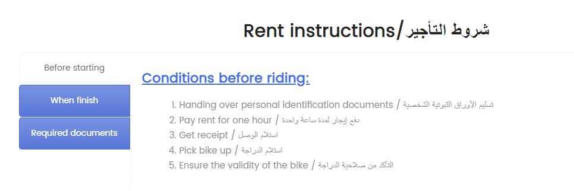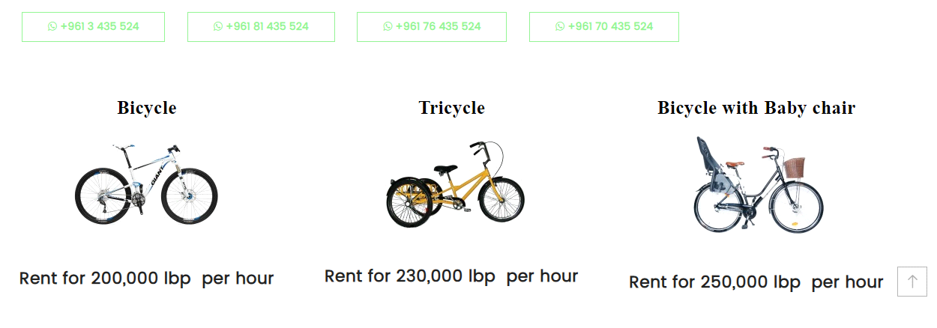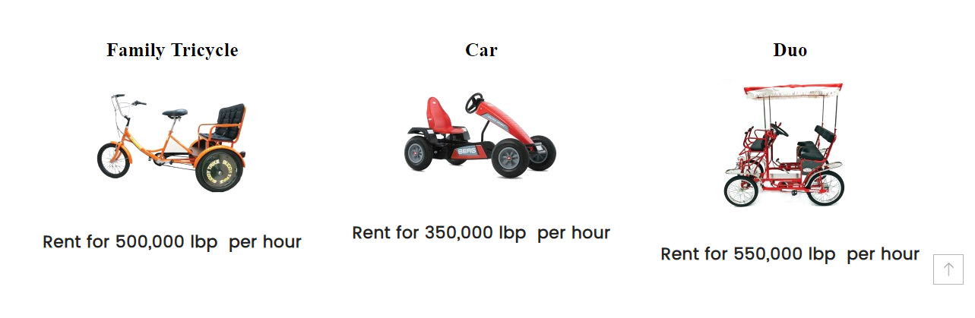

* **System 2: Wave Bike**

As commuters we are polluting the air, wasting a lot of time in traffic, and lacking time to exercise to reduce stress and live a healthy lifestyle. This is our daily struggle.

In the absence of proper infrastructure and public transport, Wave is providing a transport solution to get our community’s back covered. Wave blends the Dutch cycling culture with the local and offers you a traffic-free and healthy lifestyle with a tailor made e-bicycle subscription.

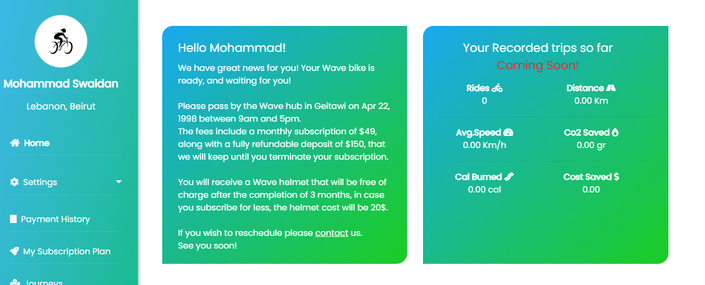

Their website can be accessed at: <https://www.wave.bike/>

* **System 3 : Biking & bike rental**

For renting a bike in Batroun there are two options. **Bike Route**, located on Batroun’s seaside road between White Beach and O’Glacee on the right, offers high quality mountain bikes for 6 USD per hour and 25 USD per day, including helmet and insurance (max. 5 hours). Their location is open open daily from 8:30 am to 6 pm and reservations for more than four bikes are a must. If you have less money to spend, **Doctor Bike** offers bikes between 2 USD and and 5 USD per hour and 20 USD for a full day, including helmet. Their little shop is located just after the seaside road. Opening times are from 8 am till 8 pm. 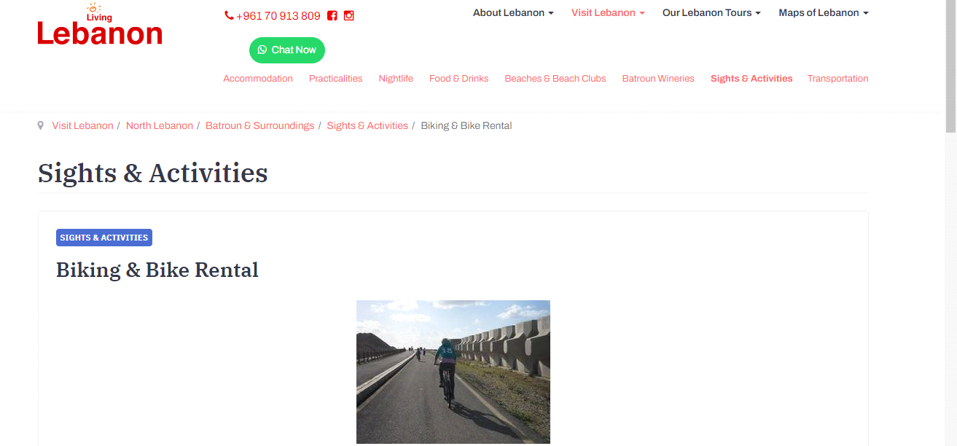

Their website can be accessed at: <https://www.living-lebanon.com/visit-lebanon/north-lebanon/batroun-surroundings/sights-activities/359-biking-batroun>

* **Systems Comparison**

This paragraph in meant to highlight the advantages and shortcomings of each of the previously stated methods **with respect to certain criteria**. We summarized these points in the following three tables.

**Table 2-1: Comparison Table Based on Graphical Interfaces**

|  |  |  |  |
| --- | --- | --- | --- |
| **Criterion 1** | **System 1** | **System 2** | **System 3** |
| **Graphical Interface** |
| Good user interface |  | ✓ | ☒ |
| Easy and effective navigation | ✓ |  |  |
| Simple and professional Design | ☒ |  | ☒ |
| Responsive | ✓ | ✓ |  |

**Table 2-2: Comparison Table Based on Content and Functionality**

|  |  |  |  |
| --- | --- | --- | --- |
| **Criterion 2** | **System 1** | **System 2** | **System 3** |
| **Content and Functionality** |
| Quality content structure |  | ✓ | ☒ |
| Usability | ✓ | ✓ |  |
| Dynamic content | ✓ |  |  |
| Content management system | ☒ | ☒ | ☒ |

**Table 2-3: Comparison Table Based on Features**

|  |  |  |  |
| --- | --- | --- | --- |
| **Criterion 3** | **System 1** | **System 2** | **System 3** |
| **Features** |
| Security measures |  | ✓ | ☒ |
| Third party integration | ✓ | ✓ |  |
| Accessible content and location | ✓ |  |  |
| Registration form | ☒ | ✓ | ☒ |

* **Conclusion and Motivation**

There is many websites that provides bikes rental services and we mentioned some of them above . Every system above has a particular advantage , and at the same time it also missed an important feature . As we see one of them is not secured and the other missed the registration form that is an important feature and so on , this makes it not desirable for all users and some people will have some difficulty to use it , as we know in this days all people avoids the websites that have low security .

As a conclusion, the mentioned systems have some drawbacks that require some

Improvements and there are many methods to improve it .

In our website we will work not to miss any feature to let users benefit from it. . The security will be very good to let the user trust it and give his information without any fear or hesitation . Moreover it will be easy and simple to be used for any person wants rent a bike without facing any problem . Also the location will be showed via Google maps that helps the tenant reach to the location exactly .

We will talk in-depth how we will do this in the next chapter .

* **System Design**
* **Introduction**

This chapter will cover in-depth about the project requirement and its functionality will be done. Also it contains many diagrams in order to identify the interactions between the system and the actors . Moreover , a state diagram, class diagram, and a sequence diagram are found in this chapter to explain the system backend design and structure of the website .

* **Requirements and Specification Analysis**

This part will explain the requirements of the project and use cases are used to facilitates the structure of the website and the features that makes it better than the similar systems . This chapter will make the work easier to understand the structure of the system and better that the others .

* **Functional Requirements**

Here you have to list the operations and activities that a system must be able to perform.

* The system requires the user to sign up for a new account.
* The system sends a verification email to the new users.
* The system allows the user to sign in as a renter or tenant.
* This system has a search feature to allow users looking for their requirements.
* This system offers new updates for the users when necessary.
* **Use Case Diagrams**

The following figure shows a use case diagram for our application. The user can perform the following actions: Register, Sign In, Logout, Add a bike, Remove a bike, Search for available bikes and rent a bike. Each action will be explained below.

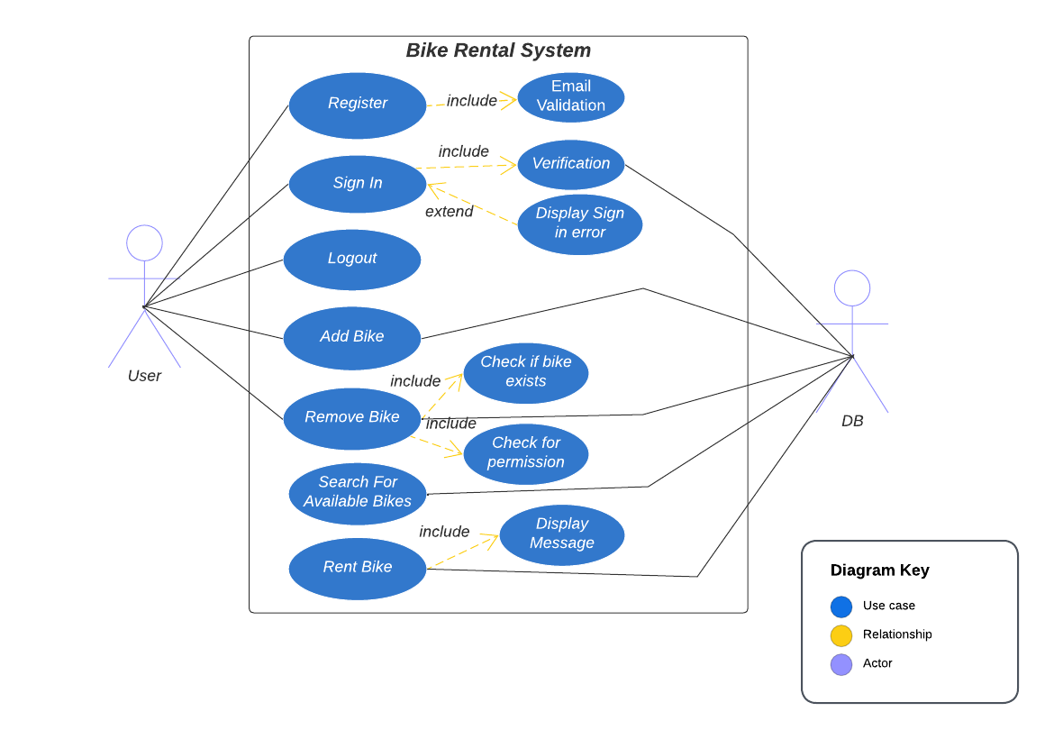

|  |  |
| --- | --- |
| **Use Case ID** | 01 |
| **Use Case Name** | Register |
| **Primary Actor(s)** | New User |
| **Purpose** | To create an account at Bike Rental System. |
| **Pre-condition** | New user must use valid registration data. |
| **Post-condition** | If successful, user account is created and added to database.  If not successful, a message will be shown to the user to fix errors. |
| **Events and steps** | 1. New user enters all the required personal information. 2. If all the parameters are valid, a new account is stored in the database, and the user can now login into the application |
| **Exceptions** | Username or email already taken |
| **Additional remarks** | None |
| **Conclusion** | With this simple registration interface, anyone around the world can become a user of our system. |
| **Use Case ID** | 02 |
| **Use Case Name** | Sign in |
| **Primary Actor(s)** | Already Registered User |
| **Purpose** | To login into Bike Rental System. |
| **Pre-condition** | User must have a valid email and password. |
| **Post-condition** | If successful, user logs in successfully to the website.  If unsuccessful, user is not allowed to login to the website and a message will be shown to him/her. |
| **Events and steps** | 1. User enters his email and password. 2. A verification is done to check whether the email and password exist in database and are correct. |
| **Exceptions** | Invalid Email or Incorrect Password |
| **Additional remarks** | None |
| **Conclusion** | Using this step, any registered user can login to his account to start using the features of our website. |

|  |  |
| --- | --- |
| **Use Case ID** | 03 |
| **Use Case Name** | Add bike or remove bike. |
| **Primary Actor(s)** | Already Registered User. |
| **Purpose** | To add a new bike or remove existing bike. |
| **Pre-condition** | User must be logged in and go to add bike page. |
| **Post-condition** | If successful, user can add his own bike to the website or remove their existing bikes.  If unsuccessful, user is not allowed add or remove his/her bike to the website and a message will be shown to him/her. |
| **Events and steps** | 1. User goes to the add bike page. 2. User add the information about his/her bike (size, color,…) 3. Users remove a bike they add it before. |
| **Exceptions** | Some necessary information missed to add a bike |
| **Additional remarks** | None |
| **Conclusion** | Using this step, any registered user can add or remove his/her own bike on the website. |

|  |  |
| --- | --- |
| **Use Case ID** | 04 |
| **Use Case Name** | Search for available bikes |
| **Primary Actor(s)** | Already Registered User |
| **Purpose** | To search for a suitable bike for the user. |
| **Pre-condition** | None |
| **Post-condition** | If successful, user can search for any available bike.  If unsuccessful, a massage appears that there is no available bike. |
| **Events and steps** | 1. User enters to search textbox. 2. Add the specifications about the bike that he/she wants to rent. |
| **Exceptions** | No bike is found in this specifications. |
| **Additional remarks** | None |
| **Conclusion** | This step will make it easy for users to search for a bike. |

|  |  |
| --- | --- |
| **Use Case ID** | 05 |
| **Use Case Name** | Rent Bike |
| **Primary Actor(s)** | Already Registered User |
| **Purpose** | To rent or reserve an available bike. |
| **Pre-condition** | User must be singed in successfully. |
| **Post-condition** | If bike is available, user can reserve it from the website. |
| **Events and steps** | 1. Go to available bikes page. 2. Search for a bike. 3. User rent the bike that he/she finds it suitable. |
| **Exceptions** | User can’t rent and already reserved bike. |
| **Additional remarks** | User can rent it for period of time. |
| **Conclusion** | After the user finds the bike that he want to rent , he/she can reserve it from the website . |

* **System Architecture**

Define the overall architecture of the system. Layered, Dataflow, Multi-tier, Client-Server, etc. It is worth noting the underlying technologies to be used. Draw a figure that shows the complete system Example of such figures:

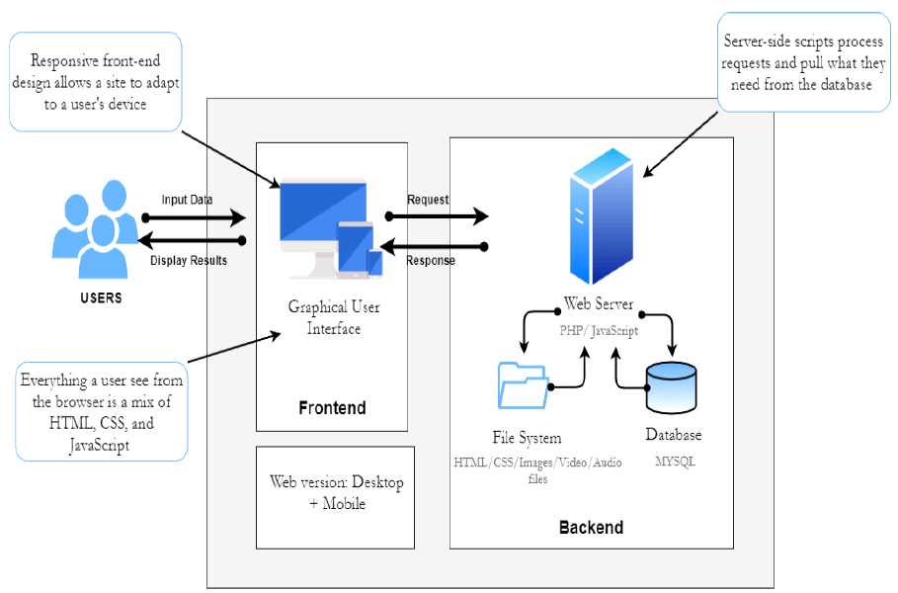

**Figure ‎3-1- System Architecture**

* **Class Diagrams**

The static design view of the system. It includes all the underlying classes designed and their hierarchy. Check this tutorial: <https://www.youtube.com/watch?v=UI6lqHOVHic>

* **Sequence Diagrams**

Sequence Diagrams are interaction diagrams that detail how operations are carried out. They capture the interaction between objects in the context of a collaboration. Sequence Diagrams are time focus and they show the order of the interaction visually by using the vertical axis of the diagram to represent time what messages are sent and when.

Check this tutorial: <https://www.youtube.com/watch?v=pCK6prSq8aw>

* **Activity Diagrams**

Activity Diagrams describe how activities are coordinated to provide a service which can be at different levels of abstraction. Typically, an event needs to be achieved by some operations, particularly where the operation is intended to achieve a number of different things that require coordination, or how the events in a single use case relate to one another, in particular, use cases where activities may overlap and require coordination.

Check this tutorial: <https://www.youtube.com/watch?v=3Hw_VXea73o>

* **Entity-Relationship (ER) Diagrams**

An entity relationship diagram (ERD) is a graphical representation of entities and their relationships to each other, typically used for modeling the organization of data within databases or information systems. Check these tutorials starting with the first one:

Tutorial 1: <https://www.youtube.com/watch?v=QpdhBUYk7Kk>

Tutorial 2: <https://www.youtube.com/watch?v=-CuY5ADwn24>

* **Non-Technical Aspects**
* **Financial Viability**

A cost benefit analysis of the project. Here is an example:

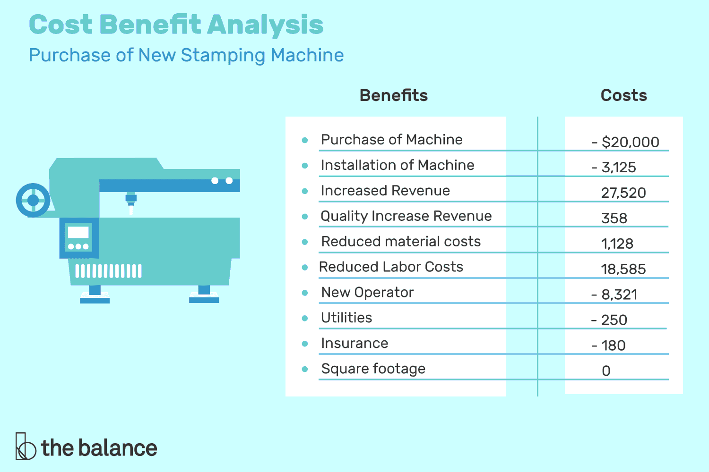

**Figure ‎3-2- Cost Benefit Analysis**

* **Stakeholders**

Who will benefit? Who may be harmed? Who should have a say in how the project works?

* **Scope**

Exactly what will be done in the project, sometimes it is helpful to state what will not be done in the project.

* **Risks**

Things that may stop the project from achieving the goals in the scope.

* **Schedule and Milestones**

What will be completed and when. Here is an example:

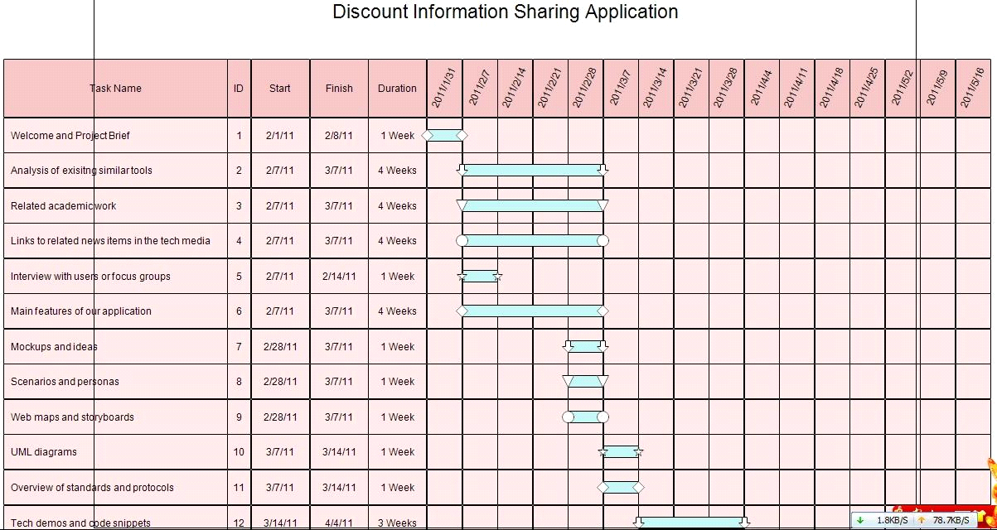

**Figure ‎3-3- Scheduling Tasks and Milestones**

* **Ethical and Social Considerations**

Are there any ethical issues that should be taken into consideration when completing the design?

* **Environmental and Sustainability Considerations**

Are there any environmental issues to write about? It is ok to write that this project has no environmental impact.

* **Relevant Standards**

List the technical (and possibly the non-technical) standards that are relevant to your design. Examples are the WiFi standard (IEEE) and International Standardization Organization (ISO).

* **Conclusion**

This paragraph in meant to draw conclusions highlighting the main ideas in this chapter.

* **Implementation/Simulation and Testing**
* **Introduction**

This paragraph in meant to introduce the topics to be covered in this chapter.

* **Implementation Tools**

List the tools used for implementing the system. This includes hardware, compilers, IDE, frameworks, CASE tools, etc...

* **Implementation Summary**

Description of detailed implementation steps. Demonstrate the typical code fragments (details of implementation, e.g. source code listings must be included in an appendix and saved on an accompanying CD/DVD)

* **Test Cases and Acceptance Criteria**

Describe the test cases used and the acceptance criteria.

* **Conclusion**

This paragraph in meant to draw conclusions highlighting the main ideas in this chapter.

* **Conclusion and Future Work**
* **Conclusion**

Any concluding remarks, lesson learned, etc…

* **Future Work**

Describe the opportunities for expanding the work done in this thesis.

**APPENDIX A:   
Implementation Details**

Any details not fit in chapter 5: e.g. detailed calculation, complex algorithms, etc…

**APPENDIXB:  
 USER Manual**

Fill in the instruction manual for using the application

**APPENDIXC:   
deployment and configuration Manual**

Outline the deployment and configuration details in addition to any know troubleshooting techniques.

**REFERENCES**

[1]: <https://www.bookingsync.com/en/resources/blog/bike-rental-software-key-features-and-benefits> by BookingSync

[2]: <https://www.bikerentalmanager.com/how-bike-rental-companies-can-benefit-from-software-solutions/> by Bike Rental Manager

[3]: <https://www.reportsnreports.com/reports/2792505-global-bike-rental-software-market-size-status-and-forecast-2019-2025.html> by ReportsnReports

[4]: <https://www.mobileappdaily.com/bike-rental-software-features> by Mobile App Daily